September 24
Dear PE Co-ordinator,
We would like to invite your school to enter the Lancaster & Heysham SSN
4/5/6/7 GLOW DODGEBALL FESTIVAL!
This event is scheduled at LANCASTER UNIVERSITY (not University of Cumbria),
on 5th December 2023 9.45-11.30
The event is back and big… in the double sportshall… in the dark!

Teams: 8 on court, Squads of 8- 10, Years 4/5/6/7.
Primary- no minimum ratio of boy/girls, secondary may be boys, girls or mixed from year 7 only.
Schools may bring 1 team and request others but last time it was full very quickly. We have a max number of 32 teams.

This is a fun based event and we will be asking pupils to display honesty. Those not playing a game will officiate their own games. It is not about winning and losing- we simply want a group of pupils to come along and have fun being active, work as a team and be with their friends and be at a bigger event again. Because of the darkened setting it has been shown to be particular good for pupils who may be more self-conscious than others.

Glow dodgeball takes place in a darkened room with ultraviolet lights that cause balls and players equipment to glow! It’s something a little different- hopefully you can pick a ‘different’ group of pupils. Secondary schools- we’d encourage you to consider choosing pupils who have possibly struggled with transition but would benefit from a fun session with peers.

There will not be an overall winner. Instead we will reward schools on ‘The Spirit of the Games’ values which are Determination, Honesty, Teamwork, Passion, and Self Belief. Hopefully it’s an opportunity for you to pick a targeted group of pupils of your choice. On your feedback forms you suggested transition was a potential issue we hope this will help… Last year we had several Year 7 Heads of Year attend with their teams and found that very useful in building relationships; and lastly, pupil health and wellbeing has been mentioned, this is a chance to have fun, be active and work as a team! Pupils not playing will also have a chance to officiate. Please dress up in your best fluorescent clothing!! For some pictures of our previous Glow event see our social media at @LHschoolsport https://www.facebook.com/LHschoolsport

Coaches can drop off at the side of the sports centre and park on the hashed areas on that side road- please let us know how you plan to travel up prior to the day. See the map below. There is also additional overflow car parking at the side of the sports centre- 2 hours of parking is free, if you arrive too early you may require £3 for the machine- we hope this is not the case but just have it in case.

Event details are as follows:
- No spectators.
- Schools encouraged to bring some team members who may have a go at officiating- We want the session to be pupils coming together, working together, having fun being active. Teachers may be required to plug gaps but formats will be informal- it’s fun based!
- Wear any luminous clothing and/or use UV pens to draw on old clothes. All those children of the 1990s- dig out your old glow sticks and wrist bands!! Fluorescent clothing and white work best. We will supply a limited amount of UV make up and glow sticks.

- Teams of 8, squads up to 10 (teams may be mixed but there are not set criteria/ratios).
- Date: 5th December; 9.45-11.30
- Venue: Lancaster University Sports Centre
- Please don’t arrive more than 15 minutes before the start & be ready in your finest UV/glow gear!
- 1 – but you may request a 2nd team, 1st come first served.
- Please can schools bring their own 1st Aid kits
- We will supply some UV gear but please can schools also be as ready as possible and perhaps bring your own too.
- It will fill up fast- The deadline entry date for this tournament is 21st NOVEMBER Enter via the website – www.lhssn.co.uk

The Venue:

- The activity is taking place in the new sportshall at Lancaster University’s Sports Centre.
- Lancaster University Sports Complex and Swimming Pool; Bailrigg, Lancaster, LA2 0PH
- On arrival, don’t park in the front car park, please drive down the right hand side of the building, at the top of the hill there is a hatched area for a drop off point.
- Parking is available in the Car Park behind the Centre and/or in the lay by at the side.
- Entrance to the Centre can be made via the glass doors at the bottom of the steps (where the drop off point is and not via the front doors of the Sports Centre)
- There are water fountains, vending machines and a vending coffee machine at the Centre.
- Although there are first aiders on site, schools should bring their own first aid kits and school staff should be the first port of call.
- Please wear clean, non-marking, footwear.

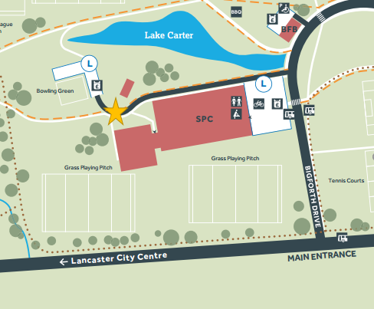

We can only do this event thanks to your SSN membership- Get ready…. Glow!!!!
Sincerely,
Steven Jamieson LHSSN & Lancaster SGO Email: jamieson.sm@gmail.com

